API SECURITY RISK ANALYSIS
REPORT

Written by: Harneet kour
Cybersecurity Task 3: Future Interns

Contents
1. Executive Summary 3
2. Scope & Methodology 3
2.1 Scope 3
2.2 Methodology 4
2.3 Tools Used 4
3. API Security Findings 4
3.1 Finding 1: Publicly Accessible API Endpoint (No Authentication Required) 4
3.1.1 Description 5
3.1.2 Evidence Observed 5
3.1.3 Risk Severity 6
3.1.4 Business Impact 6
3.1.5 Remediation 6
3.2 Finding 2: Excessive Data Exposure 6
3.2.1 Description 6
3.2.2 Evidence Observed 7
3.2.3 Risk Severity 7
3.2.4 Business Impact 7
3.2.5 Remediation 7
3.3 Finding 3: Invalid Resource Request Handling 8
3.3.1 Description 8
3.3.2 Evidence Observed 8
3.3.3 Risk Severity 8
3.3.4 Business Impact 9
3.3.5 Remediation 9
3.4 Finding 4: POST Request Simulation 9
3.4.1 Description 9
3.4.2 Evidence Observed 10
3.4.3 Risk Severity 10
3.4.4 Business Impact 10
3.4.5 Remediation 10
3.5 Summary of Postman Assessment 10
3.6 Finding 5: Public Access to Comment Resources 10
3.6.1 Description 10
3.6.2 Evidence Observed 11
3.6.3 Risk Severity 11
3.6.4 Business Impact 11
3.6.5 Remediation 12
3.7 Finding 6: Response Header Analysis 12
3.7.1 Description 12
3.7.2 Evidence Observed 12
3.7.3 Risk Severity 13
3.7.4 Business Impact 13
3.7.5 Remediation 13
3.8 Finding 7: Public Access to Album Resources 13
3.8.1 Description 13
3.8.2 Evidence Observed 14
3.8.3 Risk Severity 14
3.8.4 Business Impact 14
3.8.5 Remediation 14
3.9 Finding 8: Public Access to TODO Resources 15
3.9.1 Description 15
3.9.2 Evidence Observed 15
3.9.3 Risk Severity 15
3.9.4 Business Impact 16
3.9.5 Remediation 16
3.10 Summary of Insomnia Assessment 16
3.11 Finding 9: Response Header Analysis 16
3.11.1 Description 16
3.11.2 Evidence Observed 17
3.11.3 Risk Severity 17
3.11.4 Business Impact 17
3.11.5 Remediation 17
3.12 Finding 10: Request Header Inspection 18
3.12.1 Description 18
3.12.2 Evidence Observed 18
3.12.3 Risk Severity 18
3.12.4 Business Impact 19
3.12.5 Remediation 19
3.13 Finding 11: Response Body Analysis 19
3.13.1 Description 19
3.13.2 Evidence Observed 19
3.13.3 Risk Severity 20
3.13.4 Business Impact 20
3.13.5 Remediation 20
3.14 Finding 12: Network Timing Analysis 20
3.14.1 Description 20
3.14.2 Evidence Observed 21
3.14.3 Risk Severity 21
3.14.4 Business Impact 21
3.14.5 Remediation 21
3.15 Summary of Browser Developer Tools Assessment 22
4. API Security Assessment Findings Overview 22
5. Remediation Recommendations 23
6. Conclusion 23

1. Executive Summary
This report presents the findings of a read-only API Security Risk Analysis conducted on the publicly available JSONPlaceholder REST API. The assessment was performed to evaluate the API's security posture by examining its publicly accessible endpoints, HTTP responses, request methods, response headers, and overall implementation of common API security practices. All testing activities were carried out ethically using non-intrusive techniques without attempting to exploit vulnerabilities or gain unauthorised access.
The primary objective of this assessment was to identify potential security risks that may affect the confidentiality, integrity, and availability of an API. The evaluation focused on areas including authentication requirements, authorisation mechanisms, excessive data exposure, input validation, response header configuration, and other security controls commonly referenced in industry best practices such as the OWASP API Security Top 10. Observations were collected through manual inspection of API responses and endpoint behaviour using API testing tools.
Throughout the assessment, several security observations were identified. As JSONPlaceholder is intentionally designed as a fake online REST API for learning and testing purposes, it does not implement authentication or access control mechanisms. While these characteristics are expected for a demonstration platform, similar configurations would represent significant security risks if deployed in a production environment. Additional observations included unrestricted access to publicly available resources, the exposure of complete object data within API responses, and the absence of mechanisms such as rate limiting and user-based authorisation.
Although no exploitation techniques or malicious testing were performed, the findings demonstrate how insecure API configurations could impact organisations if comparable practices were adopted within real-world applications. Appropriate authentication, least-privilege access control, response data minimisation, and secure API configuration remain essential to protecting sensitive information and reducing the likelihood of unauthorised access or abuse.
Overall, this assessment highlights the importance of integrating security throughout the API development lifecycle. By implementing recognised security controls and regularly reviewing API configurations against established frameworks such as the OWASP API Security Top 10, organisations can significantly improve the resilience of their APIs and reduce exposure to common security threats. The recommendations provided within this report are intended to support the adoption of secure API development practices and strengthen the overall security posture of production environments.

2. Scope & Methodology

2.1 Scope
The scope of this assessment was limited to the passive security analysis of the publicly accessible JSONPlaceholder REST API. The evaluation focused on reviewing publicly available API endpoints, request methods, response structures, HTTP status codes, response headers, and data exposure through read-only requests. The assessment also considered common API security areas, including authentication, authorisation, input validation, excessive data exposure, and general security configuration.
To ensure that the assessment remained ethical and aligned with the requirements of the Future Interns Cyber Security Task 3, no exploitation attempts, vulnerability scanning, denial-of-service testing, authentication bypass techniques, or unauthorised modification of data were performed. All observations were obtained through legitimate interaction with publicly documented API endpoints and were intended solely for educational and security awareness purposes.

2.2 Methodology
A structured read-only testing methodology was followed throughout the assessment. Initially, the official JSONPlaceholder API documentation was reviewed to understand the available endpoints, supported HTTP methods, and expected response formats. Selected endpoints were then tested using an API client to observe response behaviour, status codes, request parameters, and returned data.
The collected information was analysed to identify potential security risks based on recognised API security principles. Particular attention was given to authentication requirements, authorisation controls, excessive data exposure, response header information, handling of invalid requests, and other security-related behaviours that may indicate weaknesses within an API implementation. Each identified observation was assessed according to its potential security impact and accompanied by appropriate recommendations based on industry best practices.
All testing activities remained within ethical and legal boundaries by interacting only with publicly accessible resources and avoiding any actions that could disrupt the availability or integrity of the target API.

2.3 Tools Used
- Postman was used to send HTTP requests to the JSONPlaceholder API and analyse endpoint responses, status codes, request methods, and returned JSON data. The tool assisted in identifying publicly accessible resources, observing response behaviour, and evaluating security-related characteristics without modifying any data.
- Insomnia was used as a secondary API testing tool to verify endpoint behaviour independently of Postman. It was used to inspect request methods, response bodies, HTTP headers, and server responses to validate observations made during the assessment.

3. API Security Findings

3.1 Finding 1: Publicly Accessible API Endpoint (No Authentication Required)

3.1.1 Description
A security assessment was performed on the JSONPlaceholder API endpoint:
“GET https://jsonplaceholder.typicode.com/posts”
The request was sent using Postman without providing any authentication credentials such as an API key, access token, or user login. The server successfully processed the request and returned an HTTP 200 OK response containing publicly accessible JSON data.
This observation indicates that the endpoint can be accessed anonymously. While this behaviour is expected because JSONPlaceholder is a demonstration API, exposing production APIs without authentication could increase the risk of unauthorised access and information disclosure.
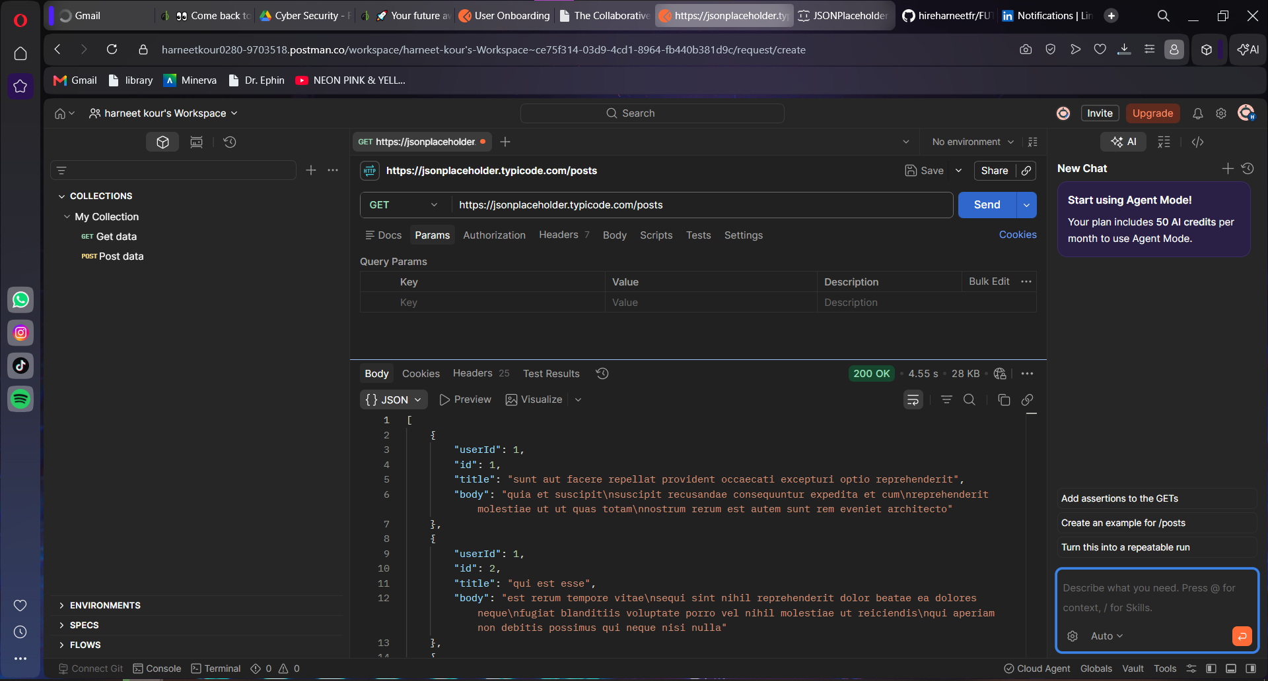
Figure 1: Successful GET request to the /posts endpoint showing publicly accessible API data.

3.1.2 Evidence Observed
- HTTP Status Code: 200 OK
- No authentication required
- Public JSON data successfully returned
- Endpoint accessible through a standard GET request

3.1.3 Risk Severity
High (acceptable for production risk analysis; JSONPlaceholder intentionally behaves this way for testing)

3.1.4 Business Impact
If similar behaviour existed in a production API, unauthorised users could retrieve business information without identity verification. Publicly accessible endpoints increase the likelihood of information disclosure, automated scraping, and reconnaissance activities by attackers.

3.1.5 Remediation
- Require authentication on sensitive endpoints.
- Implement API keys, OAuth 2.0, or JWT-based authentication.
- Apply the principle of least privilege.
- Restrict anonymous access to non-sensitive resources only.

3.2 Finding 2: Excessive Data Exposure

3.2.1 Description
A security assessment was performed on the following endpoint:
“GET https://jsonplaceholder.typicode.com/users”
The API response included complete user objects containing multiple attributes such as names, usernames, email addresses, phone numbers, websites, company information, and physical addresses.
Although the dataset is intentionally fictional, returning more information than necessary is an example of excessive data exposure. In production environments, exposing unnecessary fields can increase privacy risks and provide attackers with valuable information for reconnaissance or social engineering.

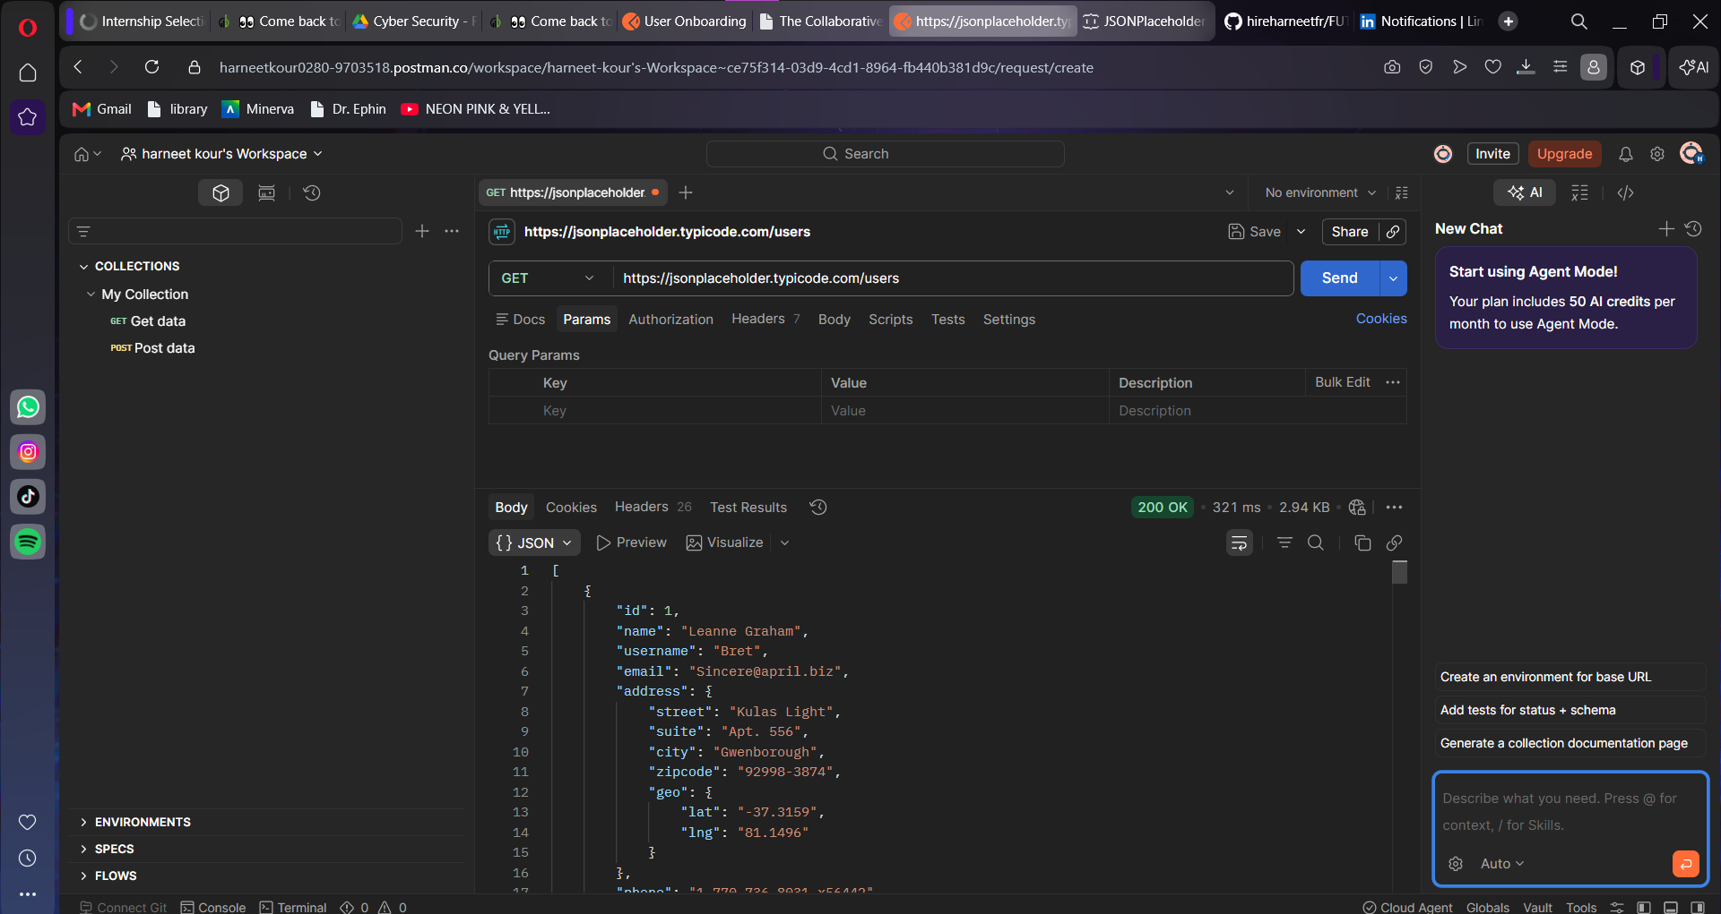
Figure 2: User information returned from the /users endpoint demonstrating publicly exposed object data.

3.2.2 Evidence Observed
- HTTP Status Code: 200 OK
- User email addresses exposed
- Phone numbers visible
- Company information returned
- Address information included in responses

3.2.3 Risk Severity
Medium

3.2.4 Business Impact
Exposing unnecessary user attributes may increase privacy concerns and assist attackers in gathering intelligence for phishing, impersonation, or targeted attacks.

3.2.5 Remediation
- Return only data required by the requesting client.
- Apply response filtering.
- Mask sensitive information where appropriate.
- Follow data minimisation principles.

3.3 Finding 3: Invalid Resource Request Handling

3.3.1 Description
The following endpoint was requested to observe how the API handles invalid resource identifiers:
GET https://jsonplaceholder.typicode.com/posts/999999
The API responded appropriately by indicating that the requested resource does not exist. Proper handling of invalid requests helps prevent unnecessary information disclosure and demonstrates predictable API behaviour.
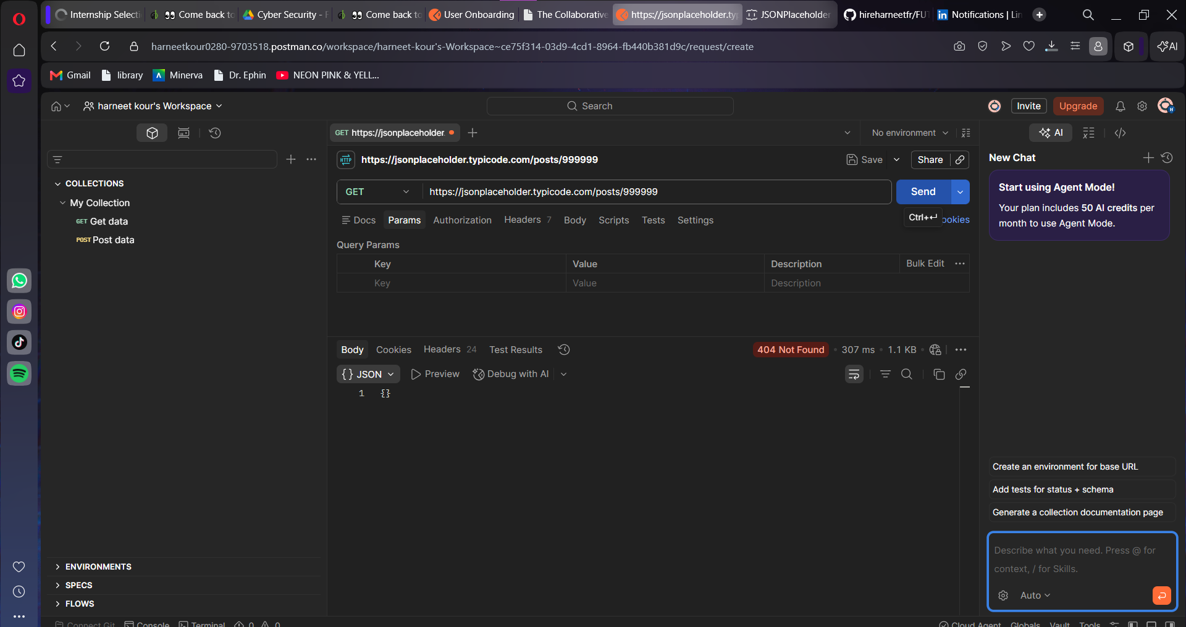
Figure 3: API response generated after requesting a non-existent resource.

3.3.2 Evidence Observed
- Invalid resource requested
- Appropriate response returned
- No sensitive server information disclosed
- Stable response behaviour observed

3.3.3 Risk Severity
Low / Informational

3.3.4 Business Impact
Proper error handling reduces the likelihood of attackers obtaining information about backend technologies or application structure through verbose error messages.

3.3.5 Remediation
- Continue returning generic error messages.
- Avoid exposing stack traces or internal server details.
- Maintain consistent error handling across all endpoints.

3.4 Finding 4: POST Request Simulation

3.4.1 Description
A POST request was submitted to the following endpoint:
“POST https://jsonplaceholder.typicode.com/posts”
A JSON request body was provided using Postman, and the API returned an HTTP 201 Created response containing the submitted data together with a generated resource identifier.
According to the JSONPlaceholder documentation, write operations are simulated and do not permanently modify server-side data. This behaviour confirms that the API is intended solely for testing and development purposes rather than production use.

Figure 4: Simulated POST request returning an HTTP 201 Created response.

3.4.2 Evidence Observed
- HTTP Status Code: 201 Created
- JSON request successfully processed
- Resource ID returned in the response
- No permanent data storage performed

3.4.3 Risk Severity
Informational

3.4.4 Business Impact
The endpoint demonstrates expected behaviour for a testing API. In production systems, POST endpoints should enforce authentication, validate all user inputs, and implement authorisation controls before processing client requests.

3.4.5 Remediation
- Require authentication before allowing write operations.
- Validate all input data.
- Implement server-side authorisation checks.
- Log and monitor write requests for suspicious activity.

3.5 Summary of Postman Assessment
The Postman assessment demonstrated that the JSONPlaceholder API is publicly accessible and responds consistently to standard HTTP requests. The analysis confirmed that API endpoints can be accessed without authentication, allowing anonymous users to retrieve publicly available resources. Response data also revealed complete user objects containing multiple attributes, illustrating an example of excessive data exposure if such behaviour were present in a production environment.
The assessment further showed that the API handles invalid resource requests in a controlled manner by returning an appropriate response without exposing sensitive server information or implementation details. Additionally, simulated POST requests were processed successfully, returning an HTTP 201 Created response while preventing permanent modification of server-side data. Overall, the observations indicate that JSONPlaceholder is intentionally designed as a testing API; however, similar configurations in production systems should be complemented with authentication, authorisation, input validation, and data minimisation controls to reduce potential security risks.

3.6 Finding 5: Public Access to Comment Resources

3.6.1 Description
A security assessment was performed on the following endpoint:
“GET https://jsonplaceholder.typicode.com/comments”
The request was sent using Insomnia without providing any authentication credentials. The server successfully processed the request and returned an HTTP 200 OK response containing publicly accessible comment data in JSON format.
The response demonstrates that the endpoint is openly accessible to anonymous users and does not require authentication or authorisation. While this behaviour is expected for a demonstration API such as JSONPlaceholder, production APIs containing user-generated content should implement appropriate access controls to prevent unauthorised information disclosure.
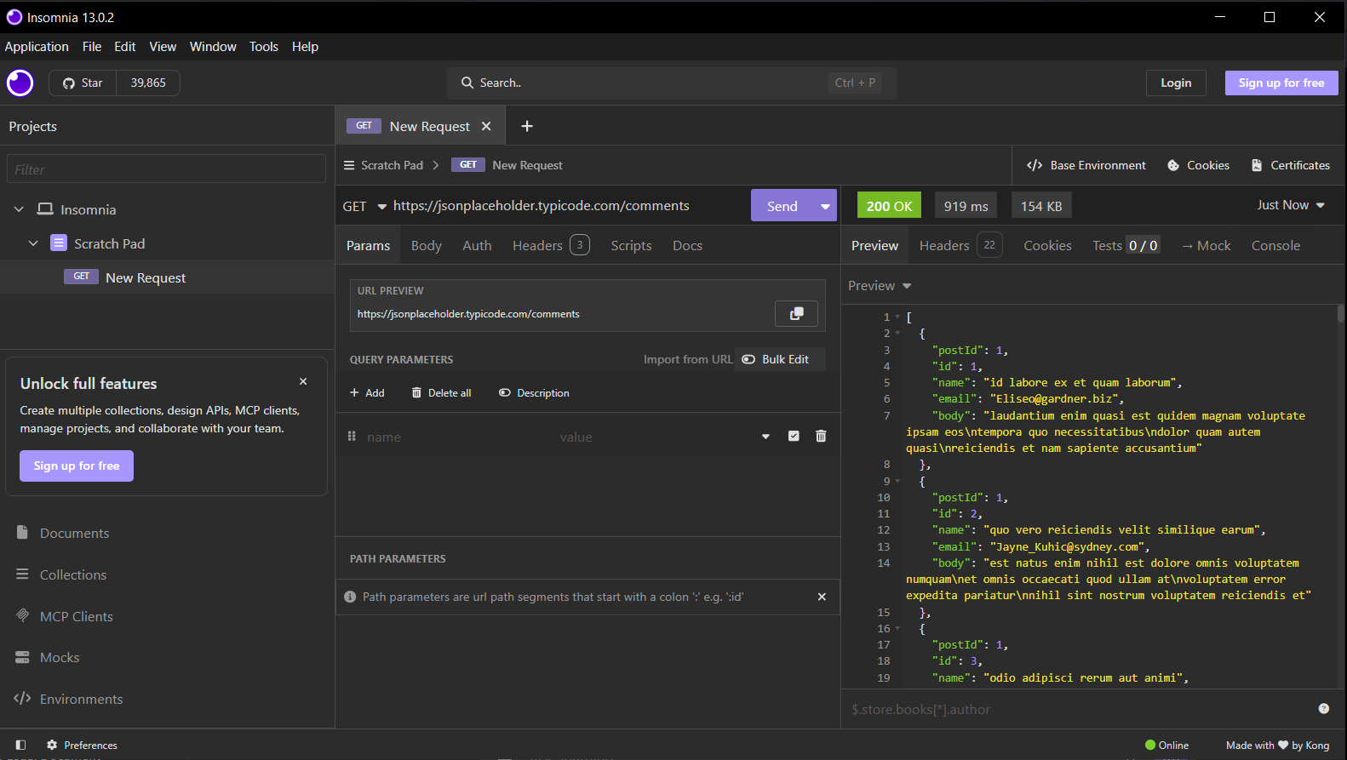
Figure 5: Successful GET request to the /comments endpoint using Insomnia.

3.6.2 Evidence Observed
- HTTP Status Code: 200 OK
- Publicly accessible endpoint
- No authentication required
- Comment data successfully retrieved
- JSON response returned correctly

3.6.3 Risk Severity
Medium

3.6.4 Business Impact
If publicly accessible comment data contained sensitive or confidential information, unauthorised users could collect large amounts of information without restriction. Such exposure may assist attackers during reconnaissance or information gathering activities.

3.6.5 Remediation
- Restrict access to sensitive resources.
- Require authentication where appropriate.
- Apply role-based access control (RBAC).
- Limit publicly accessible information.

3.7 Finding 6: Response Header Analysis

3.7.1 Description
Response headers were inspected using Insomnia to evaluate the information returned by the server during API communication. The analysis focused on identifying standard HTTP headers, response metadata, and any security-related information exposed by the API.
The observed response headers included information such as Content-Type, Cache-Control, Expires, Pragma, and ETag. These headers assist clients in understanding response formatting and caching behaviour. No sensitive server implementation details or internal configuration information were identified during the inspection.
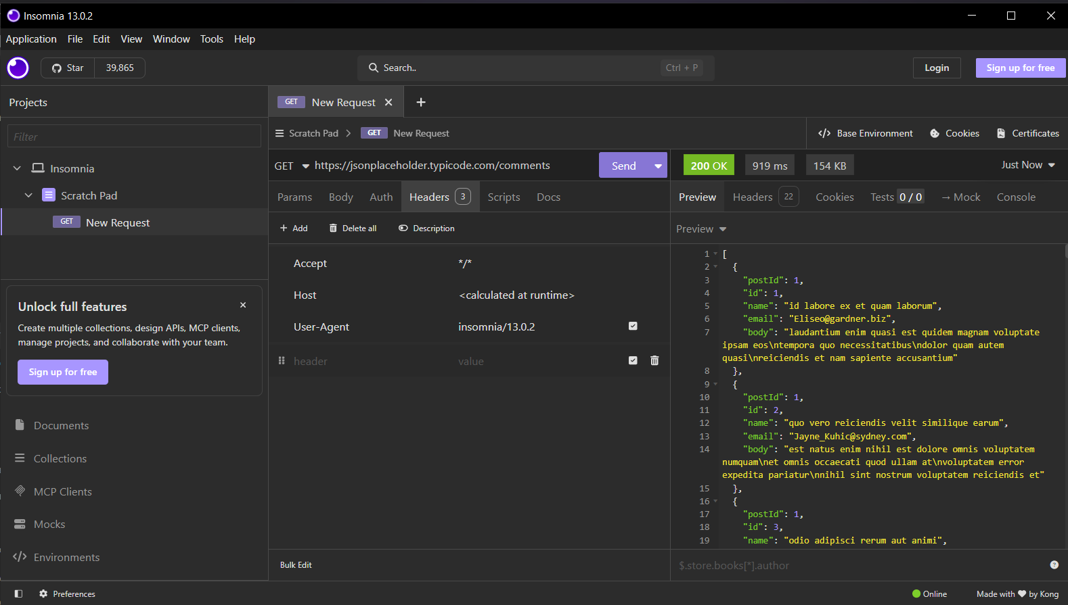
Figure 6: HTTP response headers observed using Insomnia.

3.7.2 Evidence Observed
- Content-Type header present
- Cache-Control header configured
- Expires header returned
- ETag value observed
- Standard HTTP response metadata available

3.7.3 Risk Severity
Low / Informational

3.7.4 Business Impact
Properly configured response headers improve interoperability between clients and servers while supporting efficient caching behaviour. Limiting unnecessary information disclosure within HTTP headers also reduces opportunities for attacker reconnaissance.

3.7.5 Remediation
- Continue using standard HTTP response headers.
- Remove unnecessary custom headers.
- Regularly review response header configurations.
- Minimise disclosure of server implementation details.

3.8 Finding 7: Public Access to Album Resources

3.8.1 Description
A security assessment was conducted on the following endpoint:
“GET https://jsonplaceholder.typicode.com/albums”
The endpoint returned an HTTP 200 OK response together with a collection of album resources in JSON format. No authentication or authorisation mechanisms were required before the requested data was returned.
The assessment confirmed that additional API resources remain publicly accessible through anonymous requests. Although this is appropriate for a testing platform, production systems should evaluate whether unrestricted access aligns with business and security requirements.
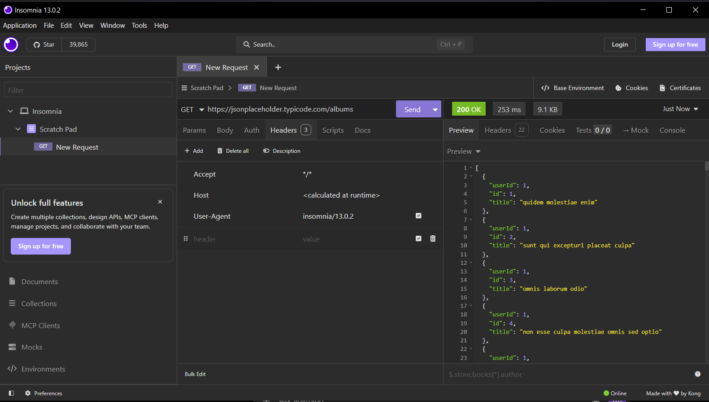
Figure 7: Successful retrieval of album resources using Insomnia.

3.8.2 Evidence Observed
- HTTP Status Code: 200 OK
- Album data returned successfully
- No authentication required
- JSON response correctly formatted
- Public endpoint accessible

3.8.3 Risk Severity
Medium

3.8.4 Business Impact
Public access to application resources may increase the risk of information harvesting if sensitive business data is exposed. Organisations should ensure only authorised users can access protected resources.

3.8.5 Remediation
- Protect sensitive endpoints with authentication.
- Apply least-privilege access principles.
- Review publicly accessible resources regularly.
- Restrict unnecessary data exposure.

3.9 Finding 8: Public Access to TODO Resources

3.9.1 Description
The following endpoint was assessed using Insomnia:
“GET https://jsonplaceholder.typicode.com/todos”
The API responded successfully with an HTTP 200 OK status code and returned a list of TODO objects. The endpoint accepted requests without requiring authentication credentials or authorisation checks.
This observation demonstrates consistent behaviour across multiple API endpoints, where publicly available resources can be accessed anonymously. While acceptable for JSONPlaceholder, production APIs should evaluate whether unrestricted access could expose sensitive operational information.
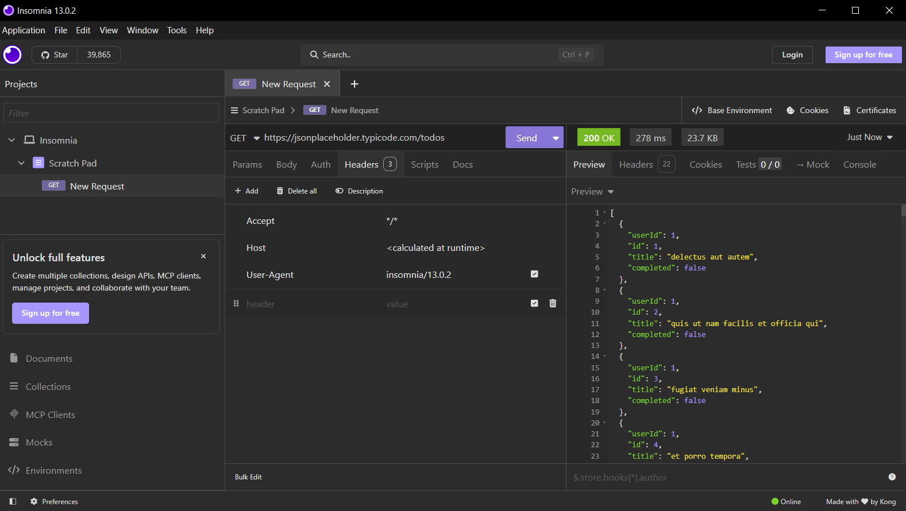
Figure 8: Public TODO data successfully returned by the API.

3.9.2 Evidence Observed
- HTTP Status Code: 200 OK
- TODO resources returned successfully
- Public endpoint accessible
- No authentication required
- Structured JSON response observed

3.9.3 Risk Severity
Medium

3.9.4 Business Impact
Unrestricted access to operational data may increase the likelihood of information disclosure or automated data collection. Appropriate authentication and access controls help reduce these risks in production environments.

3.9.5 Remediation
- Require authentication for sensitive resources.
- Implement authorisation checks.
- Apply data minimisation techniques.
- Monitor API access for unusual activity.

3.10 Summary of Insomnia Assessment
The Insomnia assessment further validated the observations identified during the Postman analysis by confirming that multiple JSONPlaceholder API endpoints remain publicly accessible and consistently return successful responses to unauthenticated requests. The evaluation demonstrated that resources such as comments, albums, and TODO items can be retrieved without requiring authentication or authorisation, reflecting the intentionally open design of the API for development and testing purposes.
Response header analysis also provided insight into the server's communication behaviour, revealing standard HTTP headers used to manage content formatting, caching, and response validation. No sensitive server information or unnecessary implementation details were observed within the inspected headers. Overall, the assessment confirmed that the API operates reliably across different testing tools while highlighting the importance of implementing authentication, access control, and secure response configurations when deploying similar APIs in production environments.

3.11 Finding 9: Response Header Analysis

3.11.1 Description
A security assessment was performed by inspecting the response headers returned by the JSONPlaceholder API using Chrome Browser Developer Tools. The analysis focused on evaluating the HTTP response headers transmitted by the server after processing a client request.
The observed response headers included standard HTTP fields such as Content-Type, Cache-Control, Expires, ETag, and Content-Encoding, which provide information regarding response formatting, caching behaviour, and content delivery. No unnecessary server implementation details or sensitive configuration information were identified within the response headers during testing.
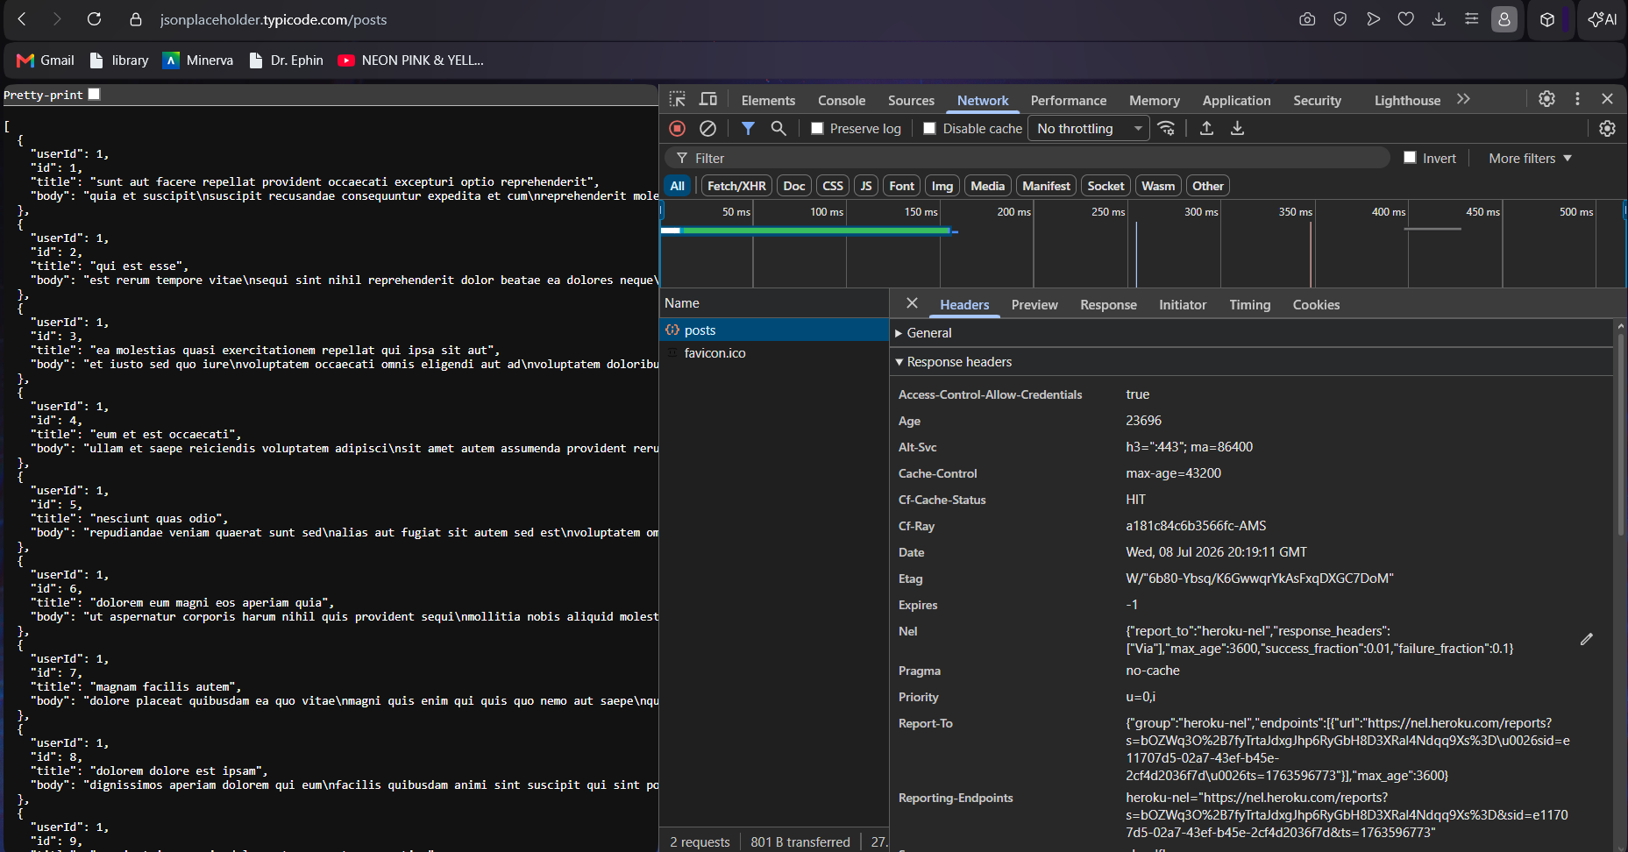
Figure 9: Response headers captured using Chrome Browser Developer Tools.

3.11.2 Evidence Observed
- Standard HTTP response headers identified
- Content-Type configured correctly
- Cache-Control and Expires headers present
- ETag header available for cache validation
- No sensitive server information disclosed

3.11.3 Risk Severity
Low / Informational

3.11.4 Business Impact
Properly configured response headers improve communication between clients and servers while reducing unnecessary information disclosure. Regular review of response headers helps organisations minimise reconnaissance opportunities for attackers.

3.11.5 Remediation
- Continue using secure HTTP response headers.
- Periodically review exposed header information.
- Remove unnecessary custom headers where applicable.
- Follow industry best practices for response header configuration.

3.12 Finding 10: Request Header Inspection

3.12.1 Description
The request headers generated by the client were inspected using Chrome Browser Developer Tools to analyse the information transmitted to the JSONPlaceholder API. Request header analysis assists in understanding how client requests are constructed and how browsers communicate with web services.
The inspection identified standard request headers including Host, User-Agent, Accept, Accept-Encoding, and Accept-Language. No authentication credentials, API keys, or authorisation tokens were present within the request, confirming that the selected endpoint accepts anonymous requests.
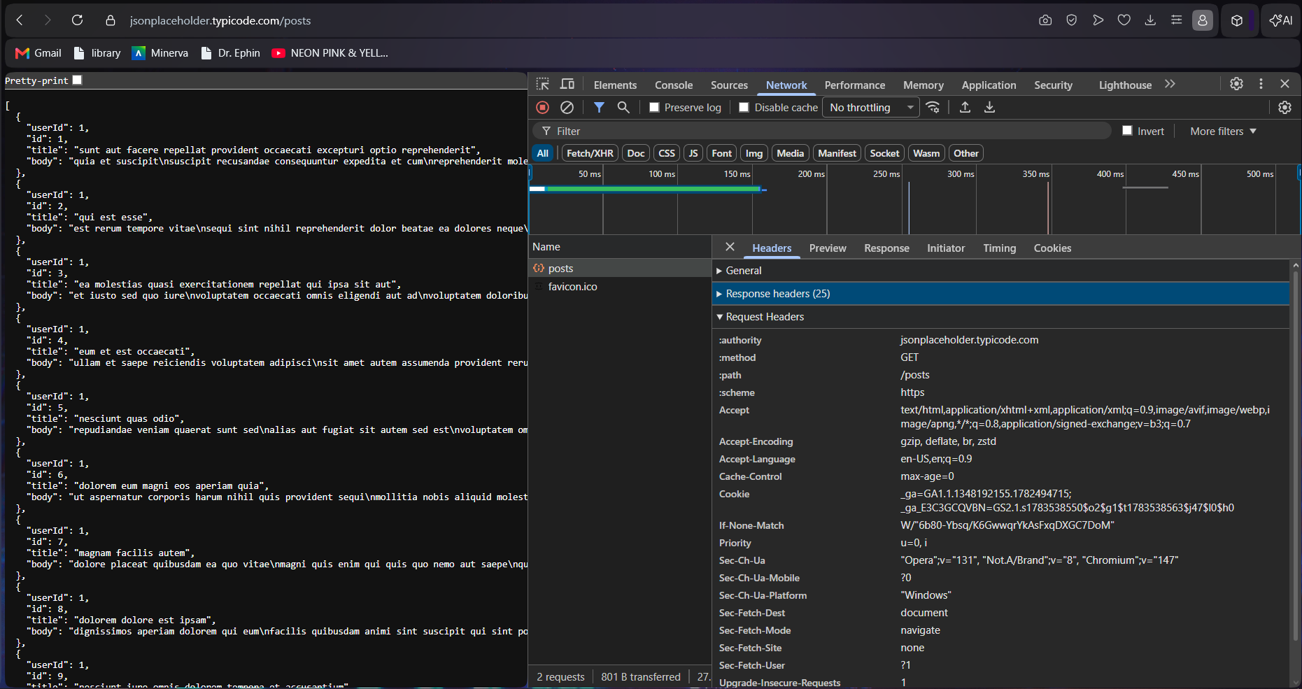
Figure 10: Request headers observed during communication with the JSONPlaceholder API.

3.12.2 Evidence Observed
- Standard browser request headers observed
- GET request method used
- No Authorization header present
- No API key included
- Request transmitted successfully

3.12.3 Risk Severity
Medium

3.12.4 Business Impact
The absence of authentication credentials confirms that the endpoint permits anonymous access. While suitable for a public testing API, production systems should require appropriate authentication mechanisms before processing requests for protected resources.

3.12.5 Remediation
- Require authentication for sensitive endpoints.
- Implement secure API key or token-based authentication.
- Monitor incoming requests for suspicious activity.
- Apply access control based on user roles.

3.13 Finding 11: Response Body Analysis

3.13.1 Description
The response body returned by the JSONPlaceholder API was inspected using Chrome Browser Developer Tools to evaluate the structure and content of the returned JSON data.
The API successfully returned structured JSON objects containing resource information requested by the client. The response confirmed that data is delivered in a consistent format suitable for application development and testing. The assessment also demonstrated that publicly accessible resources can be retrieved without requiring authentication.
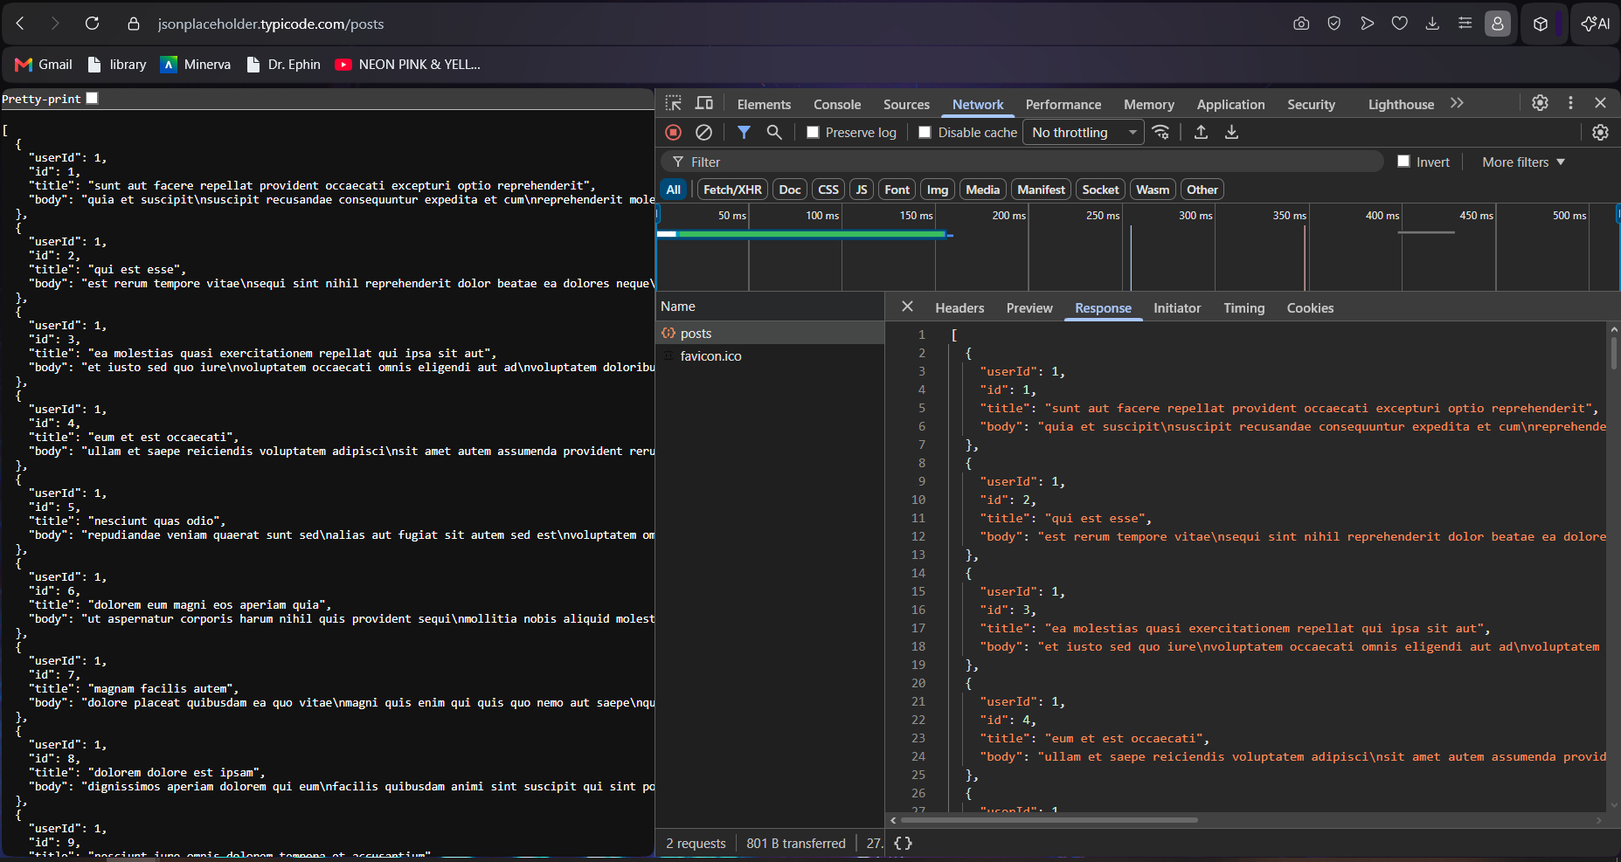
Figure 11: JSON response body inspected using Chrome Browser Developer Tools.

3.13.2 Evidence Observed
- Structured JSON response returned
- HTTP Status Code: 200 OK
- Requested resource successfully retrieved
- Data formatted correctly
- Publicly accessible information returned

3.13.3 Risk Severity
Medium

3.13.4 Business Impact
Returning structured JSON responses improves API usability for developers; however, publicly exposing complete datasets without authentication may increase the risk of information disclosure if implemented within production environments.

3.13.5 Remediation
- Return only necessary information.
- Apply data minimisation principles.
- Protect sensitive resources with authentication.
- Regularly review publicly exposed API responses.

3.14 Finding 12: Network Timing Analysis

3.14.1 Description
Network timing information was reviewed using Chrome Browser Developer Tools to analyse the performance characteristics of the API request. The Timing tab provides detailed information regarding request processing, server response time, and content download duration.
The assessment confirmed that the API responded efficiently, with no unusual delays or interruptions observed during communication. The timing information provides useful performance metrics that can assist developers in identifying potential bottlenecks and monitoring application responsiveness.
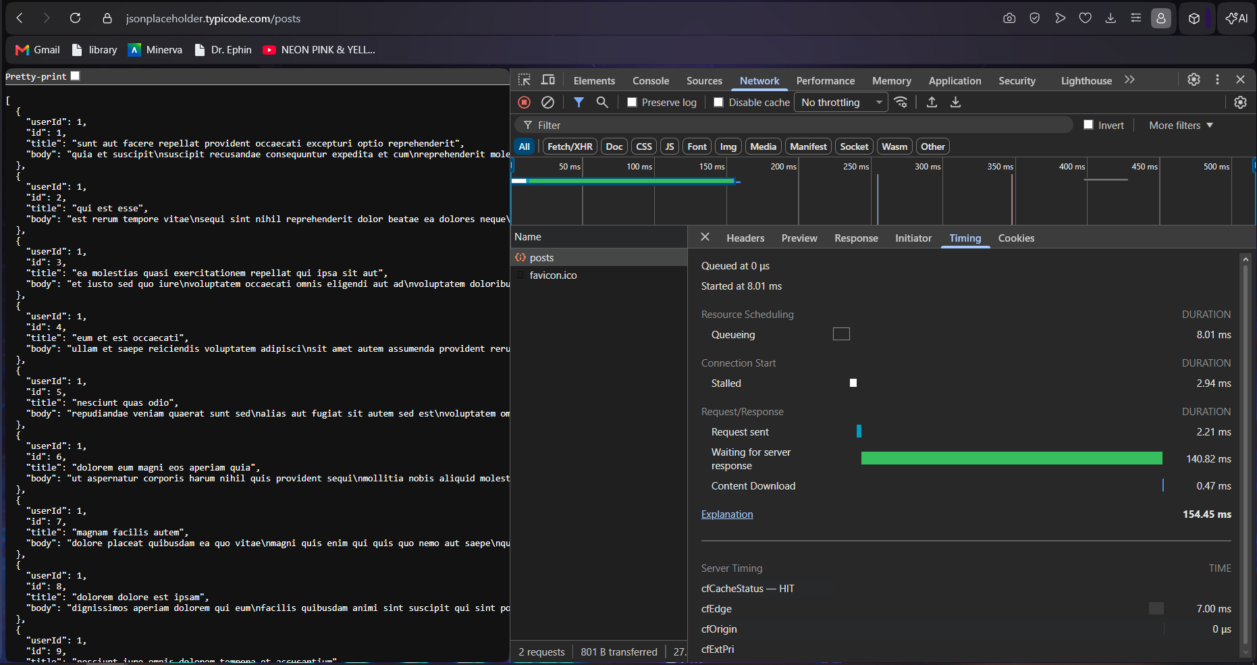
Figure 12: Network timing analysis captured using Chrome Browser Developer Tools.

3.14.2 Evidence Observed
- Request processed successfully
- Response received without errors
- Timing metrics available
- Stable communication observed
- Normal request processing behaviour

3.14.3 Risk Severity
Informational

3.14.4 Business Impact
Monitoring network timing assists organisations in maintaining API performance and availability. Consistent response times contribute to a reliable user experience and may help identify performance-related issues before they affect production services.

3.14.5 Remediation
- Continuously monitor API response times.
- Optimise server performance where necessary.
- Regularly review network latency.
- Implement performance monitoring and alerting mechanisms.

3.15 Summary of Browser Developer Tools Assessment
The Browser Developer Tools assessment provided additional visibility into the communication between the client and the JSONPlaceholder API by analysing request headers, response headers, response content, and network timing information. The inspection confirmed that the API returns well-structured HTTP responses with standard header configurations and delivers JSON data in a consistent format. The analysis also verified that requests are processed without authentication, reinforcing observations made during the Postman and Insomnia assessments.
Overall, the browser-based inspection demonstrated stable request handling, predictable response behaviour, and efficient communication between the client and the API. While these characteristics are appropriate for a public testing platform, production APIs should implement stronger authentication, minimise exposed information, and continuously monitor both security and performance to maintain a robust security posture.

4. API Security Assessment Findings Overview
Sr. No. | Finding | Category | Risk Level | Evidence
1 | Public API Access Without Authentication | Authentication | High | HTTP 200 OK response without authentication
2 | Excessive Data Exposure | Information Disclosure | Medium | Complete user objects containing personal information
3 | Invalid Resource Request Handling | Error Handling | Low / Informational | Invalid resource returned controlled response
4 | Simulated Resource Creation | API Functionality | Informational | HTTP 201 Created response from POST request
5 | Public Access to Comment Resources | Access Control | Medium | Public comment data accessible anonymously
6 | Response Header Analysis | Security Configuration | Low / Informational | Standard HTTP response headers observed
7 | Public Access to Album Resources | Access Control | Medium | Album resources returned without authentication
8 | Public Access to TODO Resources | Access Control | Medium | TODO resources accessible through anonymous requests
9 | Response Header Inspection | Security Headers | Low / Informational | Standard response headers identified in DevTools
10 | Request Header Inspection | Request Analysis | Medium | No authentication credentials present in request headers
11 | Response Body Analysis | Information Disclosure | Medium | Structured JSON response containing publicly available data
12 | Network Timing Analysis | Performance Monitoring | Informational | Stable response time and successful request processing

5. Remediation Recommendations
Based on the observations identified during the API security assessment, the following recommendations are provided to improve the security posture of APIs deployed within production environments:
- Implement strong authentication mechanisms such as API keys, OAuth 2.0, or JSON Web Tokens (JWT) to ensure only authorised users can access protected resources.
- Enforce role-based or attribute-based access control to prevent unauthorised users from accessing sensitive API endpoints or data.
- Apply the principle of data minimisation by returning only the information required for each request and avoiding unnecessary exposure of user or system data.
- Validate and sanitise all client-supplied input to reduce the risk of malicious input and improve the reliability of API operations.
- Configure HTTP response headers according to recognised security best practices and periodically review exposed header information to minimise information disclosure.
- Implement rate limiting and request throttling to reduce the risk of automated abuse, denial-of-service attacks, and excessive resource consumption.
- Monitor API activity through comprehensive logging and auditing to identify suspicious behaviour, repeated failed requests, and potential security incidents.
- Encrypt all API communications using HTTPS and regularly verify Transport Layer Security (TLS) configurations to protect data during transmission.
- Conduct periodic API security assessments and vulnerability reviews using recognised frameworks such as the OWASP API Security Top 10 to identify emerging risks and improve overall security.
- Establish a continuous security review process to ensure API configurations, authentication mechanisms, and access controls remain effective as the application evolves.

6. Conclusion
This API Security Risk Analysis evaluated the publicly accessible JSONPlaceholder REST API using a passive, read-only assessment methodology in accordance with the Future Interns Cyber Security Task 3 requirements. The assessment examined API endpoints, request and response headers, response bodies, HTTP status codes, and network behaviour without attempting exploitation or unauthorised modification of data.
The analysis identified several observations relating to authentication, access control, information disclosure, response handling, and API communication. As JSONPlaceholder is intentionally designed as a public testing platform, unrestricted endpoint access and simulated write operations are expected characteristics rather than security vulnerabilities. Nevertheless, these observations demonstrate how similar configurations could introduce significant risks if implemented within production environments containing sensitive business or user information.
Overall, the assessment highlighted the importance of implementing robust authentication, effective authorisation, secure response configurations, and data minimisation practices to strengthen API security. Regular monitoring, adherence to secure development principles, and continuous assessment against recognised industry standards such as the OWASP API Security Top 10 will assist organisations in maintaining secure, resilient, and trustworthy API services.

